Assignment 5
Topic: Stack-Based Calculator for Expression Validation and Evaluation

Name: Soham Ajit Puri
Roll. No: 04
Branch: CSDS_C1

Problem Statement: Simulate a calculator that checks and evaluates complex expressions using stack-based validation (e.g., matching parentheses, postfix evaluation).
Objective:
- Validate complex arithmetic expressions using stack-based techniques.
- Convert valid infix expressions to postfix (Reverse Polish Notation).
- Evaluate the postfix expression to produce the final result.

Prior Theory:
- Stack Data Structure
- A stack is a Last-In-First-Out (LIFO) data structure.
- Operations:
  - Push: Insert element on top.
  - Pop: Remove element from top.
  - Top/Peek: View the top element.
- Stacks are commonly used in compilers, calculators, and parsing algorithms.
- Expression Validation
- Parentheses in an arithmetic expression must always be properly matched.
- Example: (3+5)*2 is valid, but ((3+5) is invalid.
- Algorithm (using stack):
  - Scan the expression from left to right.
  - Push (onto stack.
  - When encountering), check if stack has matching (.
  - If mismatch or stack is empty → invalid.
  - At the end, if stack is empty → valid.
- Infix and Postfix Notation
- Infix: Operator between operands (e.g., 3+5).
- Postfix: Operator after operands (e.g., 35+).
- Postfix removes ambiguity and eliminates the need for parentheses.
- Infix to Postfix Conversion
- Use a stack to handle operators according to precedence.
- Rules:
  - If operand → add directly to postfix string.
  - If (→ push to stack.
  - If ) → pop until matching (is found.
  - If operator → pop higher/equal precedence operators before pushing the current one.
- At the end, pop all remaining operators.
- Postfix Evaluation
- Use stack to compute result.
- Algorithm:
  - Scan postfix expression.
  - If operand → push it to stack.
  - If operator → pop two operands, apply operation, push result back.
  - At the end, the stack contains the final result.
CODE:

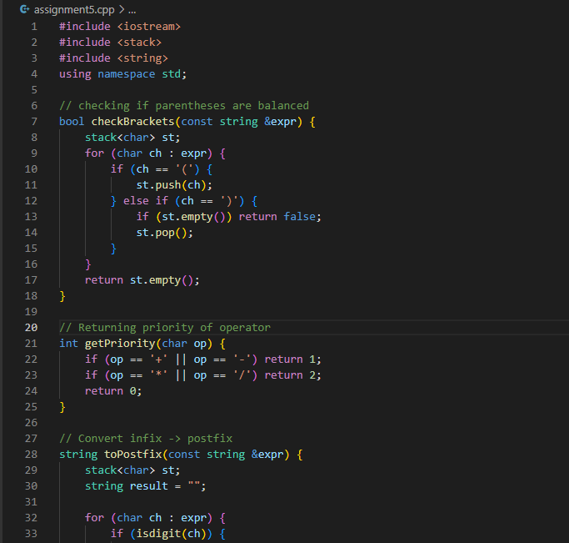

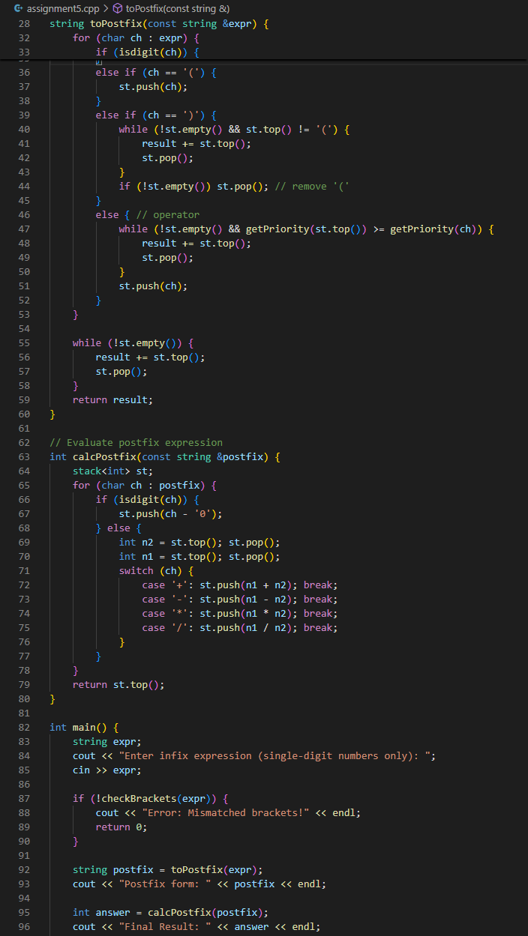
RESULTS:
    - Simple valid expression
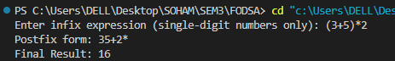

    - Expression with multiple operators
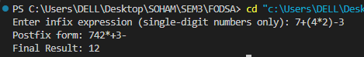

    - Nested parentheses
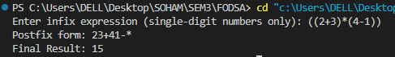

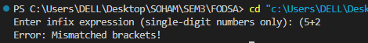
    - Invalid expression (unbalanced brackets)

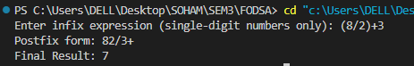
    - Division

CONCLUSION:
This assignment successfully demonstrates how the stack data structure can be applied to solve real computational problems. By using stacks, the program validates expressions for balanced parentheses, converts infix expressions into postfix form, and evaluates them step by step. The approach ensures correct handling of operator precedence and grouping, making the evaluation reliable while also validating the parenthesis.

